**Name: Shiska Raut**

**Date: 1/21/2021**

1. **3D Reconstruction of a Hypertrophic Heart from chest CT Scans**

**Software used: ScanIP**

**Major program features used:**

1. **Automatic Thresholding**
2. **Island Removal**
3. **Opening, Closing, Erosion**
4. **Recursive Gaussian Smoothing**
5. **Binary Subtraction**

**3D Reconstruction showing chambers of the heart(blue: right chambers; red: left chambers):**

**Automatic Thresholding for pericardium reconstruction(light blue):**

**Automatic thresholding for Myocardium (pink):**

**Myocardium after using binary subtraction to remove chambers and pericardium:**

**Final 3D reconstructed model of heart myocardium:**

**Model Imported into SOLIDWORKS after recursive gaussian smoothing (enlarged septum and thickening of ventricular walls as a result of the disease can be easily seen):**

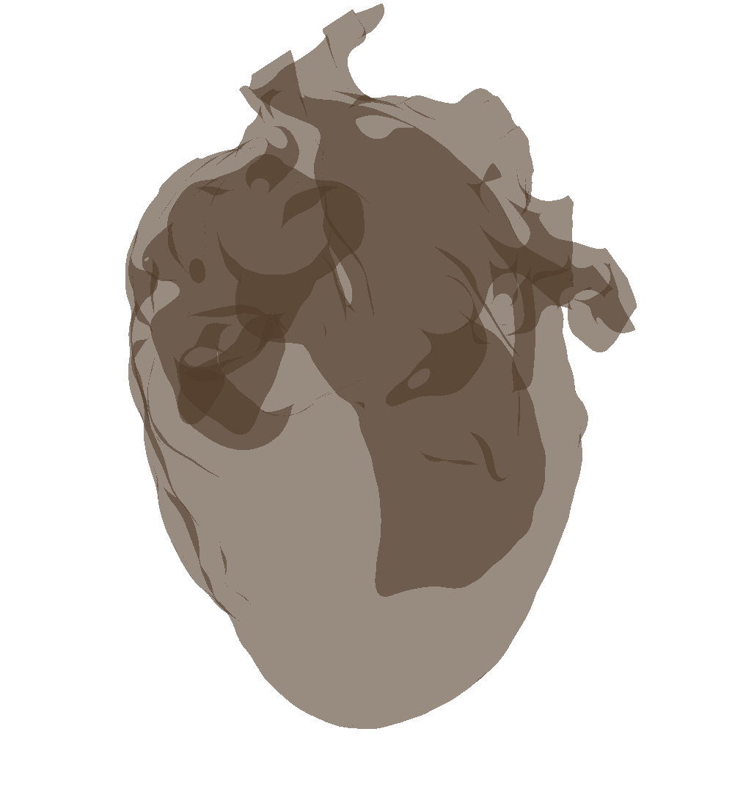

Abnormally thick ventricular wall

Enlarged Septum

**Selection view for better visualization in SOLIDWORKS:**

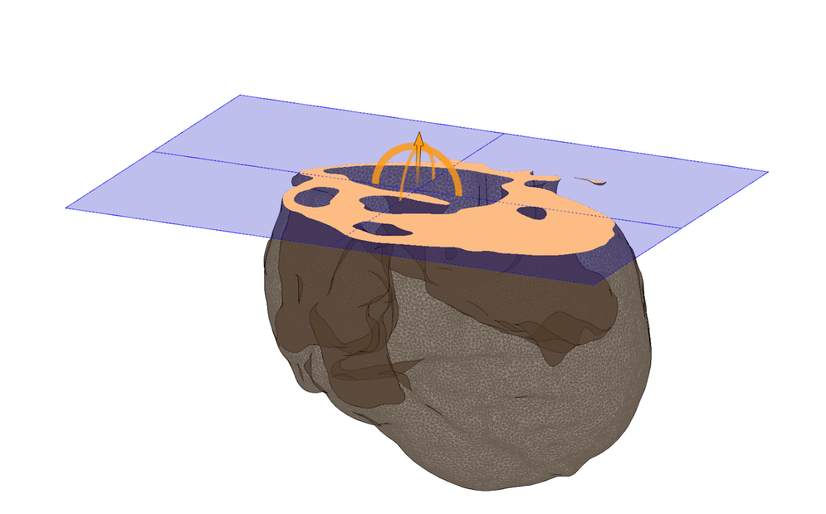

**Assessment of wall thickness on ScanIP:**

**3D Reconstruction of Left ventricular Outflow**

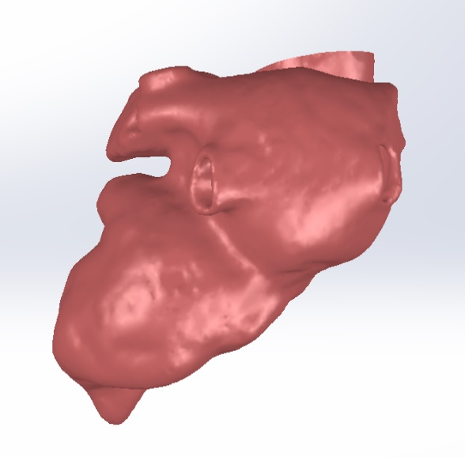

**Pelvic Bone 3d Reconstruction Project**

1. Open MITK Workbench: MITK workbench was downloaded, installed and opened for 3D reconstruction.

1. Upload DICOM images. Pelvis CT scans in DICOM format were downloaded from canvas and uploaded into the workbench for reconstruction.

1. Create bounding box for cropping: Crop option was selected and a bounding box was created around the 3D scans in such a way that no portion of the pelvic bones was left outside the bounding box.

1. Adjust box parameters, select proper size: Proper size of the box was selected and unwanted regions around the area of interest was discarded via cropping.

1. Choose segmentation and name “Pelvic Bones”: Segmentation was started, and part was named as “pelvic bones” color resembling that of bones was chosen.

1. Apply threshold: Proper thresholding was applied to select only the pelvic bones in the region to create a 3D reconstruction.

1. Create smooth polygon model: After careful thresholding, the 3D rendering of the pelvic bones was created by choosing “smooth polygon model” to make sure the surface topography of the model is smooth.

1. Volume rendering: Volume rendering of the 3D model was created by adjusting color parameters for better visibility of the bone.

1. Record video: FFmpeg movie maker was downloaded and installed as an external program under movie maker preferences. A video of the 3D rendering was recorded and saved as an mo4 file.

